**A Rioja for the Michelin Guide**

**Great Britain & Ireland 2025 Ceremony**

**Rioja Alavesa, February 2025. Bodegas Izadi, from DOCa Rioja, became last February 10th the official wine of the award ceremony of the new Michelin Guide Great Britain & Irland stars that took place in the city of Glasgow. This new Guide 2025 proclaimed a new tri-starred restaurant, two new 2-starred restaurants and 22 restaurants that get their first star.**

**Izadi** was the wine chosen to pair with the ceremony that unveiled the new stars of Ireland and Great Britain. The winery located in the Rioja Denomination of Origin, which has its roots in gastronomy in the hands of its founder, Gonzalo Antón, was the **protagonist in Glasgow** of the most relevant gastronomic event in this area and one of the most exciting in recent years.

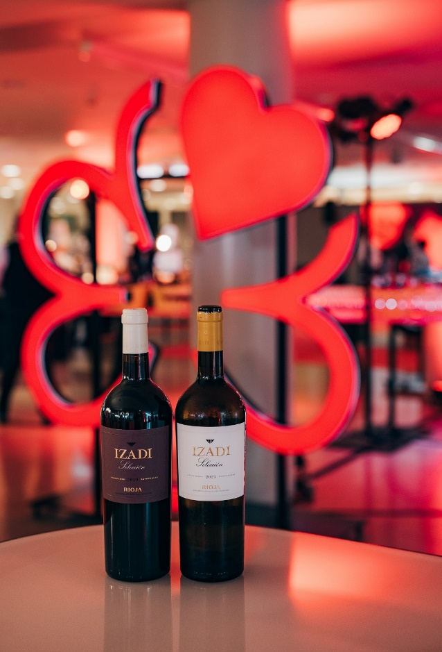

The event, which took place at the **Kelvingrove Art Gallery and Museum in Glasgow**, gathered the candidates from Ireland and Great Britain. This **Rioja winery**, **whose origins are also found in gastronomy**, was the **wine that was served during the cocktail after the awarding of the stars**. Specifically, the chosen wine was **Izadi Selección, red and white, very Riojan wines**, as they are made from all the native red varietals covered by the denomination.

**For Lalo Antón, CEO of Bodegas Izadi**, *“we are in front of a milestone in our history. Forty years ago, when we produced our first crianza, it was impossible to think that we would get to be miles kilometers away from Villabuena de Álava sharing table with some of the best chefs of the world”.*

This **2025 edition** Will be remembered for the proclamation of **Moor Hall**, located in Aughton, West Lancashire (England), as the **new three-star** of Michelin Guide, the highest distinction of this publication. Furthermore, two London restaurants – **Humble Chicken and the Ritz** – and **Hide and Fox restaurant** achieved their **second star**.

***Notes:*** Bodegas Izadi was founded in 1987 by Gonzalo Antón, a renowned hotelier from Vitoria. Currently, his son Lalo Antón runs this winery, parent company of Artevino Family Wineries (Finca Villacreces, Bodegas Vetus and Orben). Izadi is located in Villabuena de Álava, in the heart of the Rioja Alavesa. Restlessness, sensitivity, hospitality and respect mark the way of understanding the 187 hectares of old vineyards it manages. Its wines: Larrosa Rosé, Larrosa Blanca, Larrosa Negra, Izadi Selección and Izadi El Regalo VS. In 2023 it received the Best Of wine tourism award for its sustainable practices.

***For more information:***

Bodegas Izadi- Iván Pérez – iperez@artevino.es - 616 51 05 86 - [www.izadi.com](http://www.izadi.com)

Prensa -10vcomunicacion – [victoria@10vcomunicacion.es](mailto:victoria@10vcomunicacion.es) – 629 682 802